[https://www.dropbox.com/scl/fo/uvxalcry7p8ypblrt4zyu/ABmG9HHHtrfrHnYqVx-NzUk/01%20Unpaid%20Carers?rlkey=vyubq6pqwboo6dkivdwqcwpev&dl=0](https://gbr01.safelinks.protection.outlook.com/?url=https%3A%2F%2Furldefense.com%2Fv3%2F__https%3A%2Fwww.dropbox.com%2Fscl%2Ffo%2Fuvxalcry7p8ypblrt4zyu%2FABmG9HHHtrfrHnYqVx-NzUk%2F01*20Unpaid*20Carers%3Frlkey%3Dvyubq6pqwboo6dkivdwqcwpev%26dl%3D0__%3BJSU!!ASwD9k8!PT--j58g2dJUvuG76SCItHK67-j9_qP6glbazr23sall27fvOohzDC0xHGlc5l703atJtUwgILKhV9N7J7Kg7ohaHDlIPovFqAgX%24&data=05%7C02%7Cjacqui.petty1%40nhs.net%7Ca664c0b15f33424e7c7f08dda76d7675%7C37c354b285b047f5b22207b48d774ee3%7C0%7C0%7C638850810772280245%7CUnknown%7CTWFpbGZsb3d8eyJFbXB0eU1hcGkiOnRydWUsIlYiOiIwLjAuMDAwMCIsIlAiOiJXaW4zMiIsIkFOIjoiTWFpbCIsIldUIjoyfQ%3D%3D%7C0%7C%7C%7C&sdata=B7k3MnC51KPxF0b5uMsKtJ4mj3Bpz3kUpKn1Yvze7jE%3D&reserved=0" \o "Original URL: https://urldefense.com/v3/__https:/www.dropbox.com/scl/fo/uvxalcry7p8ypblrt4zyu/ABmG9HHHtrfrHnYqVx-NzUk/01*20Unpaid*20Carers?rlkey=vyubq6pqwboo6dkivdwqcwpev&dl=0__;JSU!!ASwD9k8!PT--j58g2dJUvuG76SCItHK67-j9_qP6glbazr23sall27fvOohzDC0xHGlc5l703atJtUwgILKhV9N7J7Kg7ohaHDlIPovFqAgX$. Click or tap if you trust this link." \t "_blank)

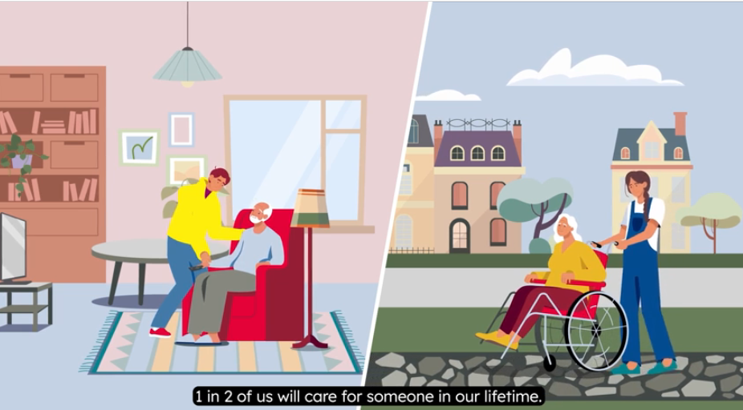

PS. It’s not too late to attend this weeks’ Carers Webinars  - click image below to register a place at any of the following:

Tues 10th June 10:00-10:30am ***Support for Adult Carers***

Wed 11th June 10:00-10:30am ***Supporting Carers of people with Dementia***

Thu 12th June 11:30-12:00pm ***Advocacy support for Carers***

Fri 13th June 1:00pm-2:00pm ***Employers support for Carers***